TESTING BANK

Chapter 1:
- There are 2 types of data, structured and unstructured. (False)
- Veracity means how much data can be trusted. (True)
- What is one example of how sensors are used to collect real-time information?
- Tracking student attendance
- Sending emails automatically
- Tracking vehicle locations using GPS
- Storing data in cloud systems
- Which one of these are NOT one of the 5Vs in Big Data (2 answers):
- Variety
- Veracity
- Visibility
- Velocity
- Viability
- Volume
- Value
5. The speed of new data created, collected and processed is called … (Velocity)
6.
7. Find the 5Vs of Big Data!
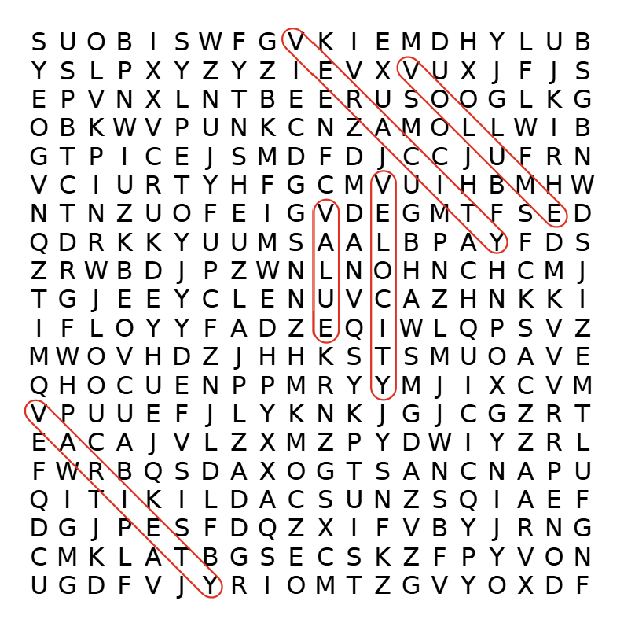
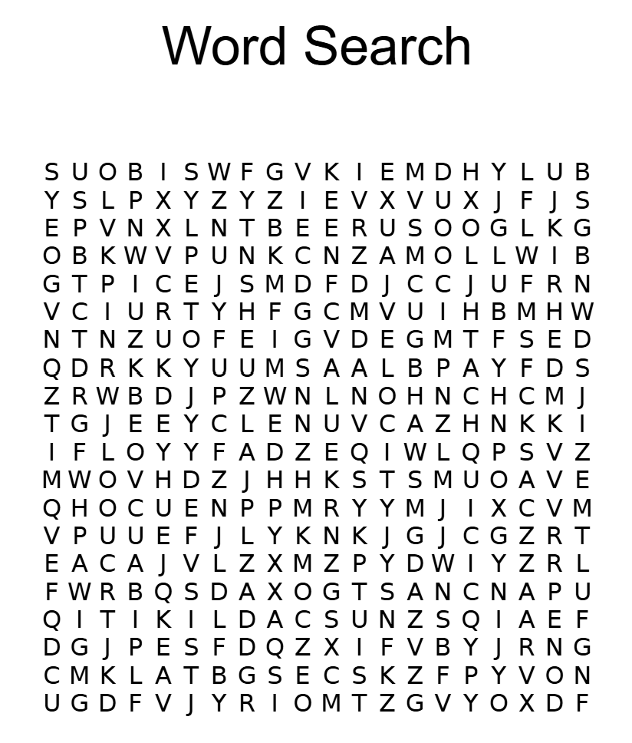

Chapter 2:
- The definition of data storage is we keep the data we collect as it is. (F)
- There are 2 categories in data collection, manual data collection is done by humans without any technology. (F)
- Which of the following best describes object storage?
a. Stores data in a folder and directory system
b. Stores data in separate blocks for fast transfer
c. Stores data as objects with metadata and unique IDs
d. Stores data in rows and columns
e. Stores data as files with metadata and stored in a hierarchical structure

- Why is data collection important in Big Data?
a. It helps reduce the amount of data that needs to be stored
b. It replaces the need for data analysis
c. It provides the foundation for accurate and informed decision-making
d. It eliminates the need for human input
e. It ensures that all data is automated
- learning about data lakes and data warehouses, explain the difference between the two with your language and give 1 example of each use case.
- Solve the crossword!
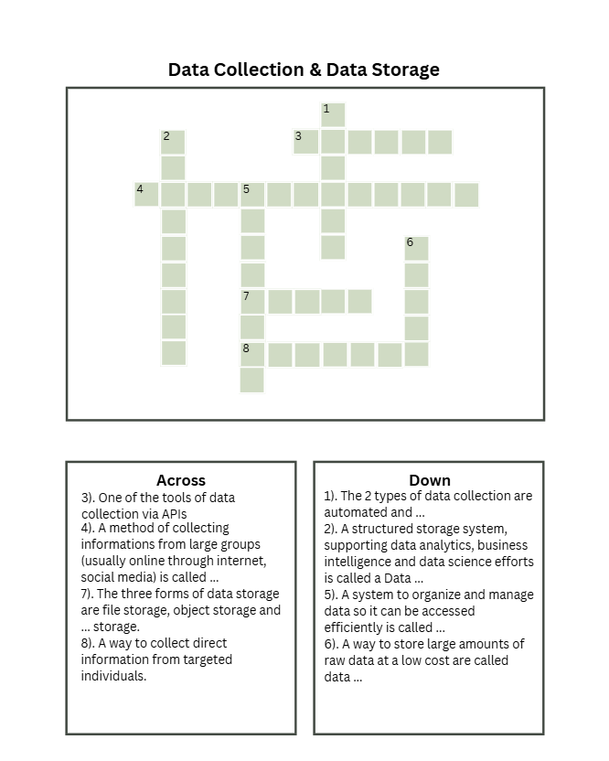
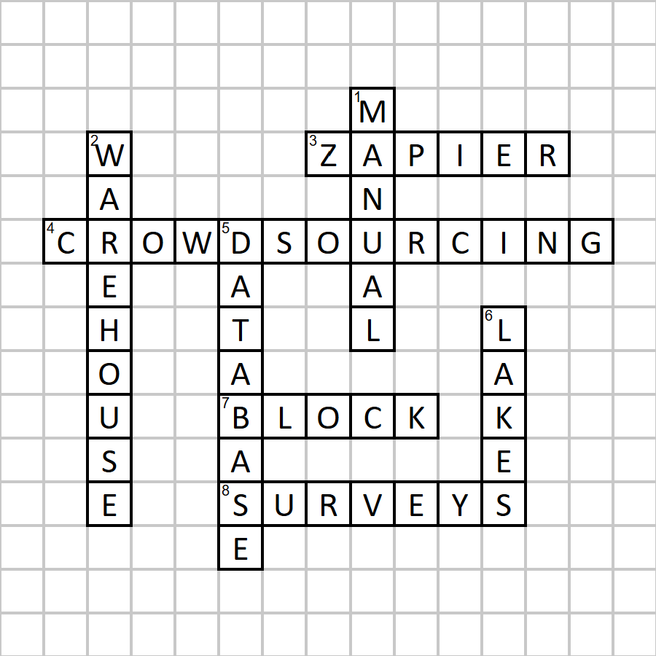

Chapter 3:
- Diagnostic analysis is considered simpler than descriptive analysis (F)
- SAS could process many datasets and work across many devices at the same time. (F)
- Tableau is friendly for beginners even if they don’t know how to code. (T)
- Which type of data analysis is primarily concerned with explaining "what happened" in the past?
a) Diagnostic Analysis
b) Predictive Analysis
c) Prescriptive Analysis
d) Descriptive Analysis
- Which tool is specifically noted for its security and dependability, making it a preference in healthcare and banking?
a) Power BI
b) Apache Spark
c) SAS
d) R Analytics
- Explain the four types of data analysis as a progressive ladder using a business scenario of your choice and explain how a company would use each type of analysis to move from understanding the past to shaping the future.
Chapter 4:
- Diagnostic analysis is considered simpler than descriptive analysis.
- SAS could process many datasets and work across many devices at the same time.
- Tableau is friendly for beginners even if they don’t know how to code.
- Which type of data analysis is primarily concerned with explaining "what happened" in the past?
a) Diagnostic Analysis
b) Predictive Analysis
c) Prescriptive Analysis
d) Descriptive Analysis
- Which tool is specifically noted for its security and dependability, making it a preference in healthcare and banking?
a) Power BI
b) Apache Spark
c) SAS
d) R Analytics
- Which of the following is best used to visualize data by region?
a) Bar chart
b) Heatmaps
c) Line chart
d) Infographic
- Explain the four types of data analysis as a progressive ladder using a business scenario of your choice and explain how a company would use each type of analysis to move from understanding the past to shaping the future.

Chapter 5:
- Which of the following best describes the main goal of Big Data governance?
A. To store as much data as possible regardless of accuracy
B. To control, protect, and manage data responsibly and effectively
C. To increase the speed of data collection without rules
D. To allow companies to share user data freely
- Why is transparency important in ethical data management?
A. It helps users understand how their data is used and increases trust
B. It hides how algorithms make decisions
C. It reduces accountability in AI systems
D. It allows companies to use data without permission
- Privacy laws like GDPR, HIPAA, and CCPA mainly focus on protecting organizations instead of individuals.
(TRUE / FALSE)
- Algorithmic bias can cause unfair or unequal treatment in AI-driven decisions.
(TRUE / FALSE)
- How can data scientists balance innovation with ethical responsibility when working with Big Data?
Chapter 6:
- Connectionist AI is based on systems of interconnected nodes called artificial neurons. (True)
- Connectionist AI learns directly from data by adjusting the strength of neural connections.
- Which deep learning architecture is best for image recognition?
- RNN
- CNN
- LSTM
- Transformer
- Which architecture uses a self-attention mechanism to understand context in language data?
- RBF
- GAN
- Transformer
- FNN
- In a neural network, the ______ layer receives raw data, the ______ layers process it, and the ______ layer produces the final result.
(input, hidden, output)

Chapter 7:
- Regression algorithms are used for predicting categories such as “spam” or “not spam.” (F)
- Supervised learning uses labeled data to train the neural network. (T)
- List the order of how neural networks train how to do its role :
(a) Loss function
(b) Weight updates
(c) Data input
(d) Backpropagation
(e) Forward propagation
a. (c) - (e) - (d) - (a) - (b)
b. (e) - (c) - (d) - (b) - (a)
c. (c) - (a) - (d) - (b) - (e)
d. (e) - (d) - (c) - (a) - (b)
e. (c) - (e) - (a) - (d) - (b)
- In reinforcement learning, what is the main goal of the agent?
a. To memorize all data
b. To predict categories correctly
c. To maximize total rewards over time
d. To label data accurately
e. To memorize what action should be done
- Describe what happens during forward propagation and why activation functions are important

Chapter 8:
- Hyperparameters are automatically learned by the model during training.
- A very high learning rate can make a model unstable during training.
- Which of the following is a disadvantage of grid search?
A. It is too random and inconsistent
B. It cannot explore all parameter combinations
C. It is computationally expensive for large parameter spaces
D. It cannot be parallelized
- What is the main purpose of early stopping in training machine learning models?
A. To increase the number of epochs
B. To prevent overfitting and save training time
C. To randomize data input order
D. To simplify model architecture
- What are two advantages of random search compared to grid search?

Chapter 9:
- A model that achieves 99% accuracy on training data but reaches only 55% on the test is described as underfitting. (T/F)
- A model that achieves 99% accuracy on training data but reaches only 55% on the test is described as underfitting. (T/F)
- L1 regularization (Lasso) is particularly useful for feature selection because it can reduce the coefficients of less important features to zero. (T/F)
- The primary purpose of data augmentation is to decrease the total training time for a model.
- A student who memorizes the answers to specific practice problems but fails when the exam questions are phrased differently is analogous to a machine learning model that is:
a) Underfit
b) Well-regularized
c) Overfit
d) Generalizing well
- Which of the following techniques works by randomly "turning off" neurons during training to prevent the network from relying too heavily on any single neuron?
a) L2 Regularization
b) Early Stopping
c) Data Augmentation
d) Dropout
- A model is too simple and fails to capture the underlying pattern in the data, performing poorly on both training and test sets. This model has:
a) High variance and low bias
b) High bias and low variance
c) High bias and high variance
d) Low bias and low variance
- Compare and Contrast: Explain the fundamental difference between how L1 and L2 regularization apply penalties to a model's weights. In what practical scenario would you prefer to use L1 regularization over L2, and why?
- Strategy and Trade-offs: Describe two different regularization techniques (other than L1/L2) discussed in the text. For each technique, explain one key benefit that helps a model generalize better and one potential drawback or challenge in its implementation.

Chapter 10:
- Which tool would most likely be used by a beginner who wants to build a simple neural network fast?
A. TensorFlow
B. PyTorch
C. Keras
D. Scikit-learn

- You train an AI to detect diseases from X-ray images, but the model performs poorly because some scans are blurry or mislabeled.
Which challenge are you facing?
A. Scalability
B. Data Quality and Availability
C. Ethical Concerns
D. Interpretability

- If an AI model keeps recommending the same type of videos or products to a user, it might be showing the “filter bubble” effect.

(TRUE / FALSE)

- Federated learning allows data from multiple hospitals to train an AI model together without ever sharing patient data directly.

(TRUE / FALSE)

- Imagine your AI system for hiring employees accidentally favors male candidates over female ones.
- What do you think caused this bias?
- How could you fix it using one of the “possible”

